DBMS LAB TEST-01

YASH GUPTA

S20200010234

* QUESTION-1

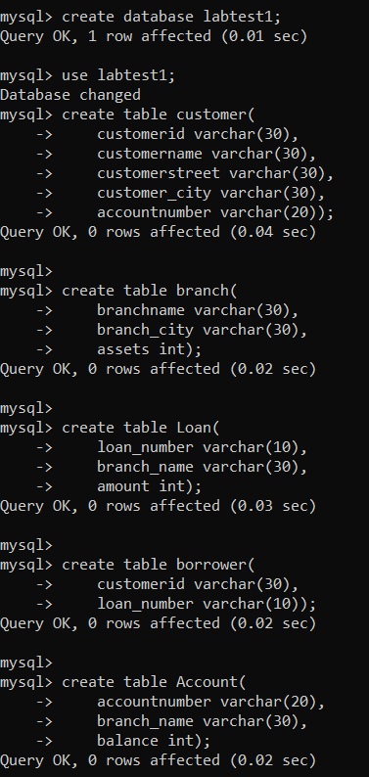



* 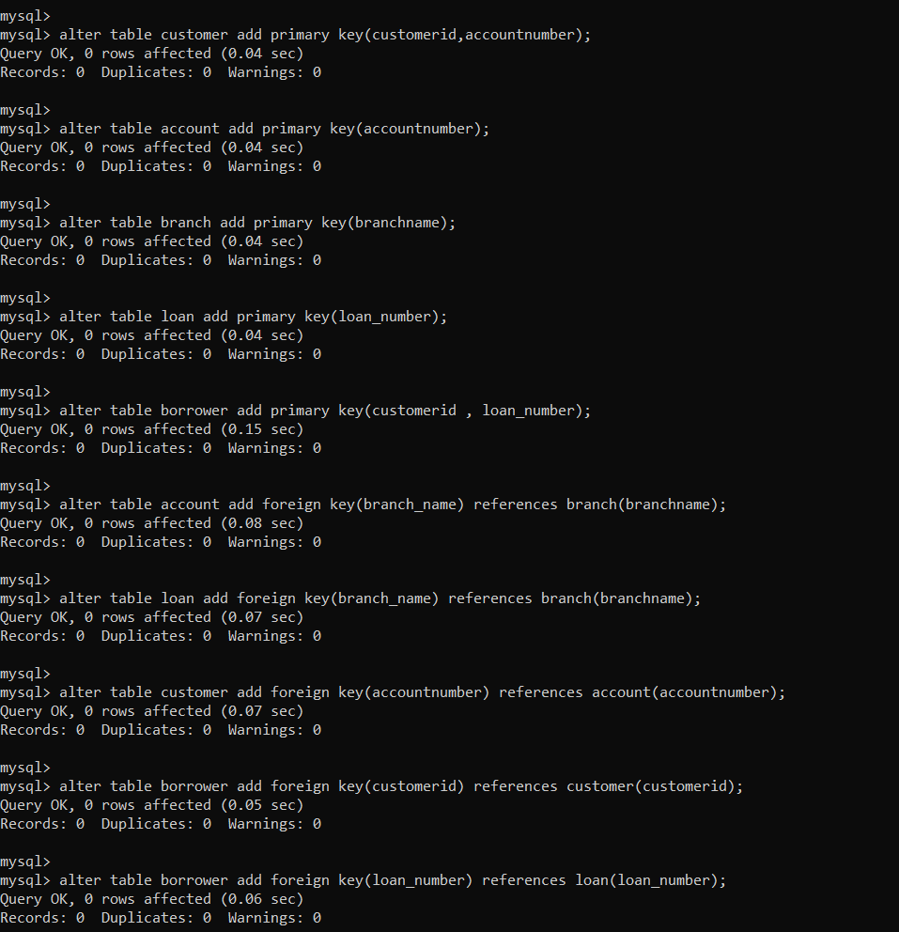QUESTION 2
* QUESTION-3 e

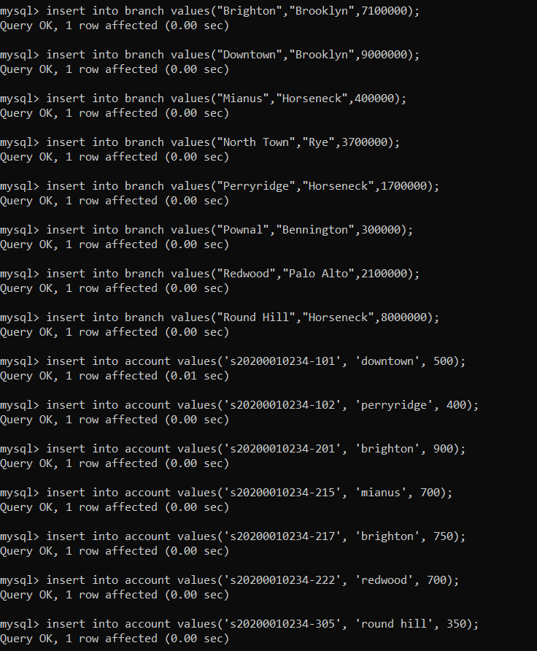

* QUESTION-3 f



* QUESTION-3 c

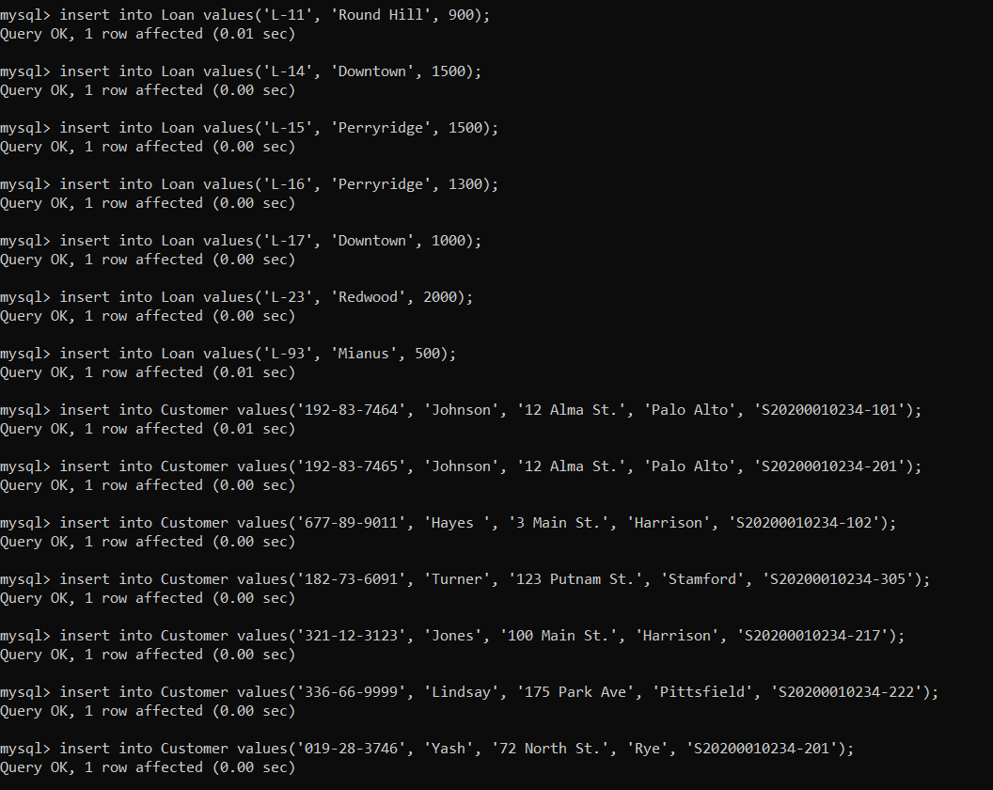

* QUESTION-3 a,b



* QUESTION-3 d

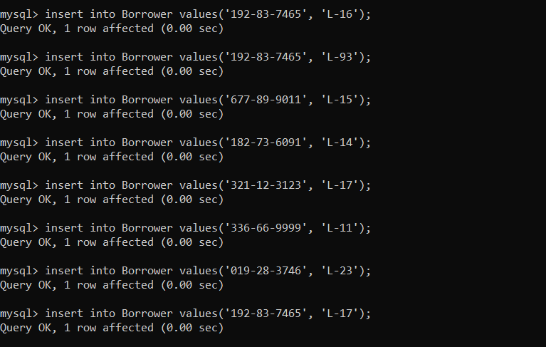

* QUESTION-5



THANK YOU